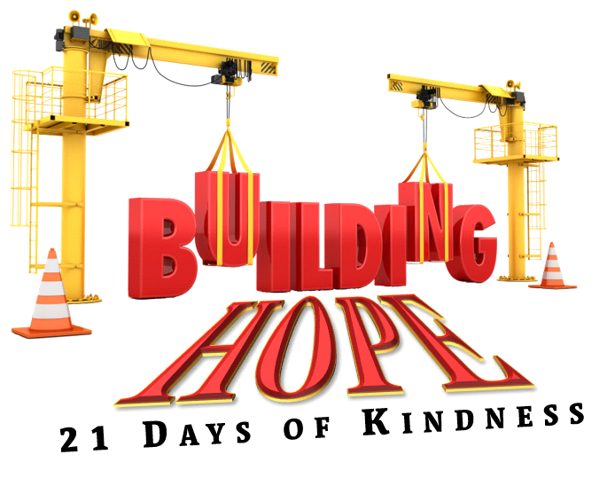

**(BH21) BUILDING HOPE Fact Sheet/Talking Points**

**WHAT** **is BUILDING HOPE: 21 DAYS OF KINDNESS?**A surge of 1021 planned and random acts of kindness throughout Birmingham & Central Alabama for 21 days to mitigate and ease the emotional distress, physical distress, and financial hardships experienced during these difficult and seemingly HOPELESS times. Building Hope: 21 Days of Kindness is a human service/awareness campaign dedicated to serving women, children, and the elderly in the most impoverished areas, and those most in need. *Building Hope will be a media and social media covered event!*

**WHO** **- Women Under Construction Network (WUCNetwork).**WUCNetwork is a nonprofit 501(c)(3) organization created to provide programs and services that support underserved women, their children, and the elderly most in need in and around the Birmingham metro area.  Our Mission: REPAIRING HOMES, BUILDING WOMEN, CHANGING LIVES!

**WHY** **21 Days?**Most acts of kindness, like feeding the hungry, serving the homeless and assisting the most disadvantaged of our population are performed primarily during major holidays**. We believe that acts of kindness should be continuous and are needed by everyone.  Some of those in need will serve shoulder to shoulder with us.**

**HOW?**  With the generous support of corporations and individuals, WUCNetwork will activate between 300 -500 volunteers in a surge of 1021 planned and random acts of kindness throughout Birmingham & Central Alabama for 21 days. Projects include:

* Home Repairs - Minor home repair projects/Grass cuts for low-income elderly & low-income single moms
* Grocery & Retail Gift Card Giveaways
* Legal Wills Clinic
* Tool Kit/Home Repair Tools Distributed
* Grocery Deliveries or Gift bags/boxes
* Bus Pass Giveaways
* Elderly Care Calls
* Volunteer support for Women in Federally Funded Public Housing Communities
* Gift Baskets to First Responders, Health professionals, Essential Workers, and Teachers
* BH21 “YOU MATTER” Care Package Distribution
* BH21 Concert (75 Female Voice Choir comprised of Event Volunteers)
* Trash Pick Up & Community Beautification Projects
* Feeding the Hungry
* Emergency Readiness Bag & Information Distribution
* AND MORE Miscellaneous Acts of Kindness!!
* **Total of 1021 Plus Acts of Kindness and Events**

**WHEN?** Beginning**June 1, 2025** and continuing through **June 21, 2025**

Please click on this Building Hope link to see 2023’s SUCCESS!!: [Building Hope Presentation](https://youtu.be/8a4U-FBTVvI)

**Please GIVE & VOLUNTEER**

**429 Green Springs Highway, #161-244, Birmingham, AL 35209 | 205-578-8929**

[**www.wucnetwork.org**](http://www.wucnetwork.org) **| Facebook: @athomefoundationinc**